**PMAS Arid Agriculture University Rawalpindi**

**University Institute of Information Technology**

**Final Term Examination-Spring-2023**

**BSCS/BSSE II- Morning & Evening**

**Database Systems CSC-103 (Theory)**

**Total Time: 105 Minutes**  **Maximum Points: 20**

**Q1: Apply normalization (1NF, 2NF and 3NF) of the system description given below and justify why relation needs 1NF, 2NF, and 3NF or not. Identify the primary key for each table and set the foreign key to link the table. (8 marks)**

**Hostel_customer Table**

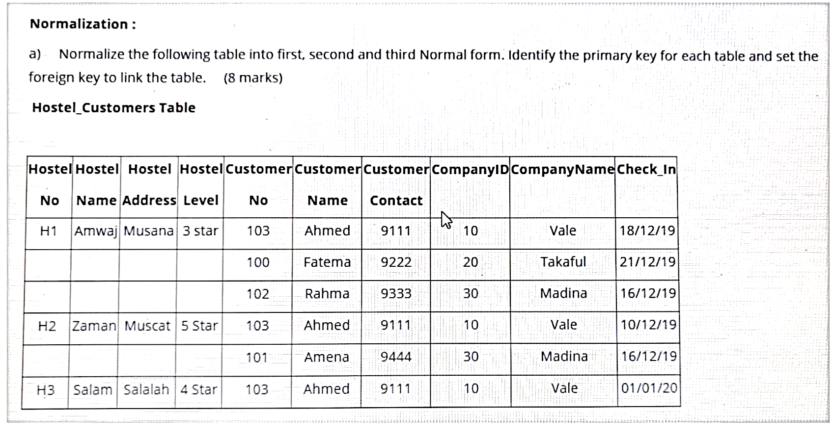

**Q2. Construct an Enhanced ERD along with Possible entity clusters of the given below system**. **(8 marks)**

Tech Desk is a small career development services company for young professionals. They provide career consultations to applicants looking for entry-level jobs. They offer three services, resume, interview practice and A-to-Z mentorship. Their process is simple. A career advisor talks with a customer to determine their background, challenges and career needs. The customer purchases the service/services that best fits their needs and signs a contract. When the contract is signed, the client department assigns the customer a client manager. The client manager assigns an industry consultant who will be responsible for delivering the services to the customer.

**____________________**

**Q3:** Production tracking is important in many manufacturing environments (e.g., the pharmaceuticals industry, children’s toys, etc.). The following ER diagram captures important information in the tracking of production. Specifically, the ER diagram captures relationships between Production Lots (or batches), individual production units, and raw materials. Please convert the ER diagram into a relational database schema. Be certain to indicate primary keys and referential integrity constraints.

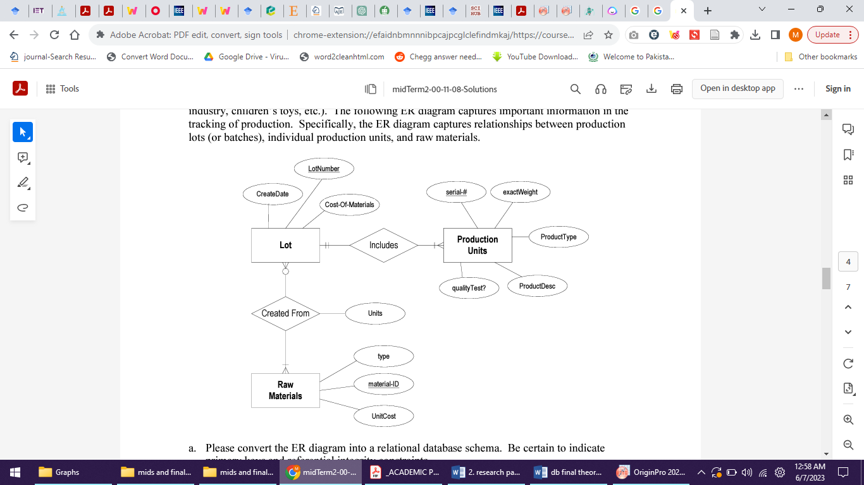

**Q.No.4. (a).** Which key decisions you will keep in your mind for creating an application system’s physical database design that will ensure its integrity and performance (**3 marks)**

**(b).** File organization is a technique to arrange records physically on a secondary storage. Mention different types of file organization. **(3 marks)**

**____________________**

**Good Luck**